Links:
Keyword Research, On-Page SEO, On-Page SEO, Technical SEO, Search engine marketing (SEM), Pay-per-click, SERPs,impressions, click-through rate, search intent, hyperlinks,
Meta Description:
Search Engine Optimization (SEO) is a technique to improve the visibility and ranking of a website by attracting traffic through organic means. Read and learn everything.
https://drive.google.com/drive/folders/1Ej9q2ta7VuyRP2FfWS91NdR-oBrVcnph
Interlinking on All recent Blogs:
SEO

What Is SEO? An Intro to Search Engine Optimization
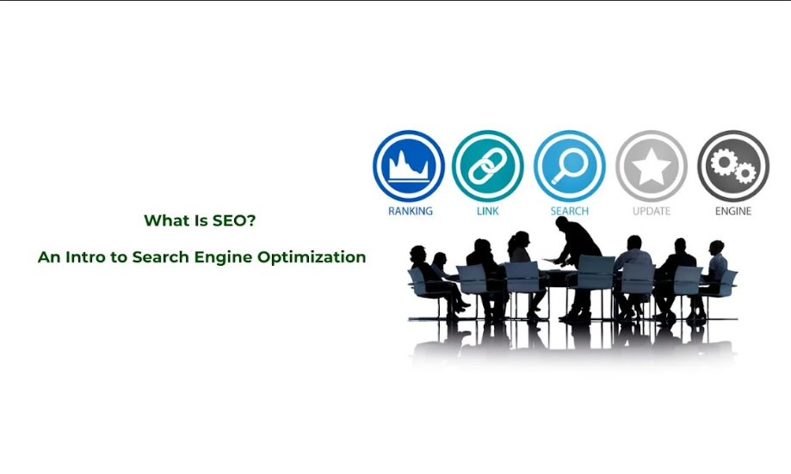
Search Engine Optimization (SEO) has caught the attention of organizations that are targeting to have better results in terms of impression, traffic, lead generation, and conversion rate.
This process involves making appropriate changes to the website content to improve its ranking on the SERP to increase organic traffic.
Let us explore what Search Engine Optimization is and why it is fundamental in the promotion of businesses online.

What Is SEO?
SEO stands for search engine optimization is an unpaid process to improve the organic ranking and traffic of a website on search engines like Google, Yahoo, and Bing.
SEO is often referred to as Organic Search Marketing, SEO Marketing, and SEO Optimization.
Through SEO, your website can easily earn a better place on search engines through organic means.
This is done by ensuring the website has proper content, arrangement of the content and other factors that make the website preferable to a search engine.
The objective is to gain a high rank on search engine results so that your brand products & services gets more exposure and could attract a lot of visitors.

Role of SEO in Digital Marketing:
Search engine optimization is an organizational juice concerning online marketing.
It enables organizations to learn about user search intent on the Internet and earn sales without buying ads. The following are benefits of SEO to a company, making it possible to enjoy organic growth in the long run:

Brief History and Evolution of SEO:
The notion of SEO has a long history especially related to the World Wide Web.
In the early 1990s, search engines came to history, and site owners discovered that it is rather crucial to be placed on the top SERP.
At first, it involves methods such as keyword overcrowding. As a result of the constant evolution of search engine algorithms, aimed at searching for the highest qualities of websites that are most suitable and preferred by users, new SEO strategies emerged gradually that are linked with high-quality content, the convenience of navigation on the site, and its overall functionality, as well as technical optimization.

Core Concepts of SEO
Here are some core concepts of SEO that deserve your attention and help you understand everything related to SEO:
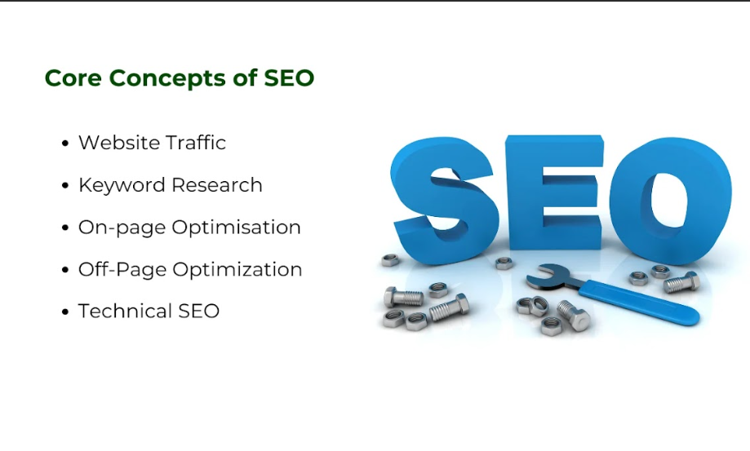
- Site Traffic: SEO is the method of using natural methods to entice people to visit a certain site. Organizing the content and structure of the websites will help businesses rank higher to get organic traffic, all without the use of paid ads.
- Keyword Research: Keywords are the foundation of any search engine optimization campaign. That’s why you must identify the most suitable keywords that will permit them to pass their message across. This entails identifying what the potential customers are likely to look for and ensuring that the website content contains these words.
- On-page Optimization: This is the process of improving website components like meta tags, headers, and contents among others to be more friendly to search engines. Good on-site optimization makes the site accessible and helps search engines to read it as quickly as possible.
- Off-Page Optimization: Establishing link juice and citations from outside your domain forms the other major activity of SEO. It involves such techniques as web linking, interaction on social media platforms, and partnership with social media influencers to enhance the site’s reputation and ranking.
- Technical SEO: Website structure is among the crucial factors that refer to the technical accessibility of a site to be crawled and indexed by the search engine. Other aspects discussed include site speed, mobile vision, and taking measures for secure connection (HTTP).

SEM vs. SEO:
SEM which stands for search engine marketing is a broader term, which covers both aspects paid (PPC) and unpaid (SEO).
As for the differences between SEO and SEM, the former is all about organic optimization, while the latter comprises paid methods. Yeah, for better results both are needed to have a complete strategic approach to digital marketing.

Why SEO Matters for Your Digital Strategy?
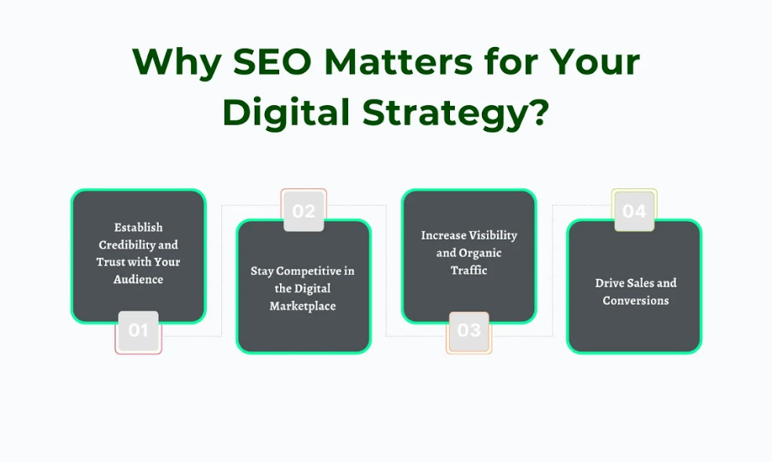

Establish Credibility and Trust with Your Audience:
Increased rank on SERP contributes to the brand's reputation and credibility. Users who come across any website on top of SERPs are likely to consider that website more authoritative and credible. This trust is very important in ensuring that visitors transform into customers.

Stay Competitive in the Digital Marketplace
Competition is high, especially in the current world that has embraced the use of the internet.
In this competitive market SEO assists companies by enabling them to dominate rivals, thanks to the sought-after resource. This also enhances the chance of your brand being seen before other brands from the competitors with which you are competing for a similar market.

Increase Visibility and Organic Traffic:
SEO increases the accessibility of a website through search engine listing services. The organic traffic is the ideal way through which websites can achieve more growth in no time for their businesses.
This also helps in securing a wider market by marketing products or services to them so they will be inclined to patronize the business.

Drive Sales and Conversions:
SEO targets the users who actively look for the relevant product or service your brand is offering. By satisfying these needs, it is possible to increase the return on investment your brand expects to make.
Search engine optimization can be very useful for increasing the conversion rate and the rate of sales because it targets the right traffic at the right time.

How SEO Works: A Step-by-Step Guide
To understand the process of SEO, it is crucial to first explain how search engines work, as well as what the search engines consider in determining the ranking of a site.

How Search Engines Operate: Crawling, Indexing, and Ranking
- Crawling: Search engines employ crawlers to surf the web and this is known as the worming. These bots make use of links to move from one website to another as they capture information from web pages. Indexing is the first technique of making the site accessible for crawling by search engine bots.
- Indexing: As with any search engine, information that has been collected is indexed. In the case of Google, it is the world’s largest, with the internet likened to a library of information. Here, the information is indexed or prepared in such a way that search engines will quickly locate and retrieve when some information is being searched for.
- Ranking: This is where algorithms come into play. Currently, Google and other search engines employ several formula that determines who among the pages in its index is authoritative. These determine factors allow the ranking of web pages for certain keyword searches seeking to provide the user with the most relevant links.

Understanding Algorithms and Their Updates:
Search engine involves numerous algorithms which are vital in searching for the appropriate data. These are elaborate sets of procedures by which search engines are directed on how to rank pages.
Besides, search engines update their algorithms with a view to providing relevant and better search results. The major updates may affect the website rankings; therefore, it is vital for SEO professionals to have knowledge of changes.

Ranking Factors: What Search Engines Look For
The competitiveness of the site depends on various aspects that affect its ranking on the search engine. Knowing all of them will assist you in increasing your site’s efficiency. Here are some ranking factors you should take into consideration:
- Keywords: These are the words that the users type in the engine, to search for the results of their query. You must use the correct keywords in your texts in an appropriate manner to assist in the ranking of your site.
- Content Quality: When it comes to content quality, it is widely known that search engines tend to rank high-quality, relevant, and valuable content. It should fulfill the user requirement and supply answers to questions that may be asked.
- Backlinks: These are links from other websites to your site and are regarded as approval from other websites which makes your site more credible.
- Technical SEO: Related to factors that ensure that the search engine can crawl and index your website. Such factors may include site speed, mobile-friendliness, and structured data.
- SEO: Eliminating the time spent collecting information and making navigation intuitive will result in the users staying longer on site and not bouncing. This is a good sign in the eyes of an Search Engines.

Key SEO Techniques:
SEO can be divided into four elements which are keyword research, on-page SEO, off-page SEO, and technical SEO.

Keyword Research and Strategy:
To set the ground for any effective SEO, basic gardening is an essential endeavor that needs to be conducted. Determine how the persons you are targeting in your business refer to products or services similar to the one you are offering.
Use tools like Google Keyword Planner, SEMrush or Ahrefs to find out the high volume but low competition keywords. Once you have identified them, it is then possible to use them organically in your content, meta tags, URLs etc.

On-page Optimization Tactics:
On-page SEO deals with the optimization of each web page to improve its rankings. This includes:
- Title Tags and Meta Descriptions: Such title tags and meta descriptions should be created to increase the click-through rate.
- H1, H2 tags: Every page should be divided into sections with the help of headings and subheadings (H1, H2, etc.), for a better understanding of the user and search engines.
- Internal link building: Hyperlinking or internal linking involves linking pages of the website to share ranking power which helps the user to navigate through the website.

Off-page Optimization Methods:
Off-page SEO is related to all activities on a website that happens outside the contextual boundaries of that specific site. The most straightforward way is to develop links from other legitimate sites. Other techniques include:
- Social Media Marketing: Your content should be posted on social profiles to obtain Social Media Marketing and attract customers.
- Guest Blogging: This involves writing occasional articles on other websites so that you can direct a larger audience to your site besides being linked to these sites.

Technical SEO Best Practices:
Technical SEO relates to all those aspects that enable the site to be easily crawled and to be easily understood by the search engine. Key practices include:
- Site Speed Optimization: These requirements relate to the loading speeds of the pages, A faster page loads are more friendly when it comes to the users as well as search engines.
- Mobile optimization: Your site should be equipped to support mobile users because most users use their smartphones to browse the internet.
- Schema Markup: Use this to alert search engines about the content of your post and potentially receive improved SERP presence.

Essential Tools for SEO Success:
It is very difficult to find your website progress in the vast area of ​​SEO without proper equipment. Here are some tools that will be useful as you begin your SEO campaign:
- Google Analytics: It is the tool used to measure the traffic to the website and the behavior of the people visiting the site.
- Google Search Console: Track your site in the search of Google Search Console and how users first encounter your site to determine problems with indexing.
- SEO Tools: Platforms like SEMrush, Ahrefs, and Moz offer comprehensive features for keyword research, backlink analysis, and competitive insights.

SEO as an Ongoing Process:
SEO is not a one-time or a single-stage process but a continuous process. The Search engine has become dynamic over the years and new modifications are redesigned frequently. It is important to remain relevant to these changes and pay particular attention to the increase in user experience to maintain and have a better ranking.

Adapt to Algorithm Changes:
It is considered relevant to know the changes in an algorithm from time to time. Visit forums and announcements by the search engine and follow the general SEO news sources to determine how such changes are likely to impact your relevant strategy.

Focus on User Experience:
Defining the objective of search engines that is the best results must be provided to a user. Cater the user by focusing on your site’s usability, fast loading time and relevance of the content that is being displayed.

Analyze and Refine Strategies:
It is recommended to track the performance based on the tools mentioned above regularly. I can highlight what you should be keeping and what should be kept away so that it can help in formulating the strategies in the right manner. This indicates that testing should be done regularly and that it is an ongoing process to achieve long-term SEO benefits.

Types of SEO: Customizing Strategies to Your Needs
Different types of SEO focus on specific aspects of your website and its content. These types have their peculiarities and their own needs, goals, and strategies that need to be fulfilled and achieved.
Let us have a look at some of the following types with the following distinctions:
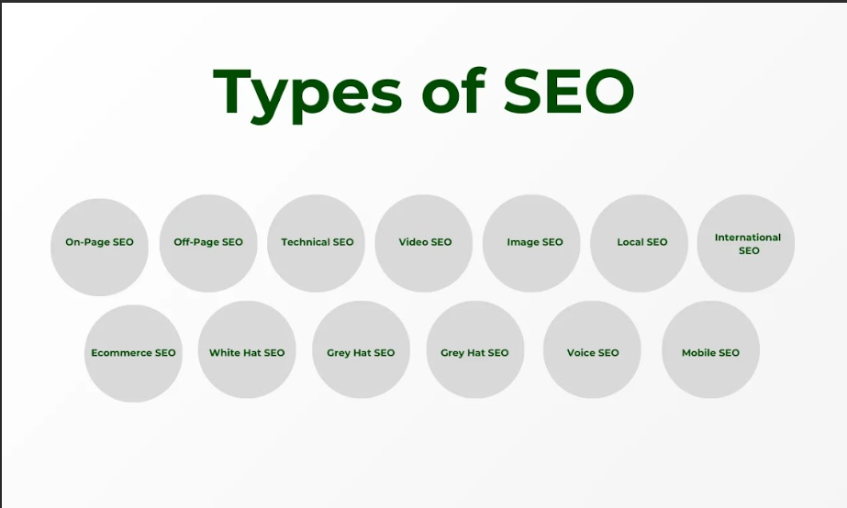

On-Page SEO:
SEO has two broad types that are on-page and off-page SEO, and in this case, On-page SEO involves optimizing single pages of the website to get more traffic.
This consists of such factors as the content, meta tags, header tags, and image tags. Keywords (Difficulty, Volume, Nature), quality and the focus on the specific user’s question should highly matter at the creation of the content. However, basic optimization of the elements such as titles and descriptions can help increase CTR obtained from the SERPs.

Off-Page SEO:
Off-page SEO refers to any SEO technique that takes place outside the company’s website but influences it in some way. Link building is the most important part of off-page SEO that involves obtaining websites’ backlinks. This informs the search engine that your site is a relevant authority to the topic being searched. Other factors that fall under off-page SEO are social media marketing and the management of online reputation, review, and mention.

Technical SEO:
Technical SEO relates to enhancing the technical aspects of your site to make it easier for crawlers and spiders to crawl and index a site. This includes site loading, which plays a significant role in user retention, and properly working site on mobile devices, as well as site structure, which should be clean and neat.
Other common SEO tasks such as fixing internal or outbound link issues, duplicate content, and absence of SSL connection (HTTPS) should also not be overlooked.

Video SEO:
Video SEO becomes also very relevant because of the trend in video content production. Search engine optimization of videos includes appropriateness of title, description, and tags particularly the keyword.
Website hosting the videos can also be done on sites such as YouTube, this is because YouTube is second only to Google as a search engine.
Developing entertaining substance engaging and high-quality videos that are valuable for the viewers could greatly enhance your page.

Image SEO:
Images are an important factor that specifically contributes to the satisfaction of a user. Image optimization involves enhancing ranking on search engines through images. This includes the name of the file, descriptions of the files, and an image map of the site. Optimization of images is crucial for both smoothening up the site’s loading time and for the SEO strategy – again, image compression does not necessarily mean a decrease in image quality.

Local SEO:
It is important for physical businesses or any business operating in a particular location, Local SEO focuses on location-based keywords. This includes non-surgical moles control, targeted aspects of your Google My Business listing, link acquisition relations from local directories, and guaranteeing that your NAP details are consistent. To get clients to your business, upcoming business listings can be utilized in the local search as well as Google Maps.

International SEO
In general, if your business targets people from around the world, you cannot do without International SEO. This refers to the process of ensuring your site has been designed to work with several languages across different regions. These involve employing hreflang tags in language targeting, creation of region-based content, and organization of web structure for languages. Businesses that go for the services of international SEO help them market their products and services to a larger market.

Ecommerce SEO
Ecommerce SEO looks at how to sell products directly through online stores by enhancing the page's ranking and the user's experience. This is by the use of the right keywords within the product descriptions, proper utilization of product images, and other factors such as the time it takes to load the page.
Extra benefits that are linked to the detailed and accurate product information, as well as the customers’ reviews and ratings, will also increase conversion.

Mobile SEO:
Mobile SEO becomes significant when it comes to mobile-first indexing. This refers to the process of arranging your pages in a way that will enable them to be within the reach of mobile device users, within a shorter duration of time as they load, and in a manner that enables them to be best suited for the small screens of mobile devices. Mobile search and mobile-friendly layout are critical factors when it comes to mobile SEO.

White Hat SEO:
White Hat SEO can be defined as the SEO techniques that have not violated any of the laid down rules of the search engines. In this approach, optimization is directed to long-term results in an attempt to deliver value to the users and increase the trust of search engines. Some white hat SEO techniques involve, developing quality content, link building strategies, and optimization of website for the user interaction.

Grey Hat SEO
It is consisting of certain techniques which are not prohibited by Search Engines but which are somewhat questionable. While most of grey hat strategies may provide the site with some benefits in the short run they may lead to some negative consequences if search engines catch up with the website.
For instance, a site gets links from other sites, and keyword stuffing is where one stuffs pages full of keywords. Before planning about Grey Hat strategies, it is always important to consider factors associated with its risks.

Voice SEO:
Due to the growing popularity of apps such as Siri, Alexa, Google Home, and others, the technique of Voice SEO has emerged. This revolves around content-friendly voice searches because these are more question-based and long-tailed. Optimizing for voice search will help to increase visibility because people will be more likely to ask questions when using voice search and your site content must provide the answers.

Landing Page SEO:
Landing Page SEO consists of the setting up of highly optimized landing pages within any given campaign or offer. Such optimization includes headlines, calls to action, and finally the page itself in terms of loading speed.

How to Get Started with SEO: A Beginner’s Guide
SEO is a very crucial technique that will assist in ensuring that your website appears on the results page of search engines such as Google. It is indeed a useful skill set for anyone, especially an entrepreneur, a marketer, and a website owner. When approaching the topic from a completely fresh standpoint. Here, Three Angle Marketing outlines how you can do it perfectly:
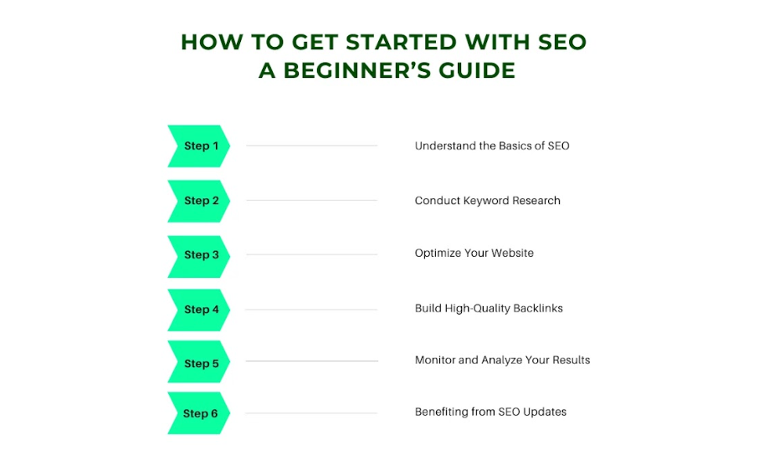

Step 1: Understand the Basics of SEO
Despite the complexity of the way it is implemented, SEO is quite basic in terms of concepts. SEO in simplest terms, is the process of making your website more friendly to the search engines for it to easily index your content. This comprises the keywords and meta tags on the web page and also the links from other pages linking to the particular web page.
It’s aim is to advance your keyword ranking on the organic search results page, improve the traffic to your site, as well as to transform mere visitors into customers.

Step 2: Conduct Keyword Research
Keywords sum up any Search Engine Optimization strategy that any site needs to enhance. Keywords are querying that potential customers may type in the search engines in their quest to find a given product or service.
Keyword research is a comprehensive process of finding out the most suitable and appropriate words to use for your business to attract traffic.
Here are some ways of developing a brilliant list of keyword ideas that you can use for your business;
- Create a list of topics based on your field of work.
- When searching for keywords associated with these topics, you should use Google Keyword Planner or particular tools like Ahrefs or SEMrush.
- Choose keywords that have high keyword volume, but low to medium competition (Keyword Difficulty) to improve your ranking.
- Rely more on long-tailed keywords because they are more specific are not as popular and have a higher chance of converting.

Step 3: Optimize Your Website
Once the keywords are defined, let’s proceed to the website optimization process. This involves making those keywords flow seamlessly in different aspects of your site like; titles, headers, meta tags, and texts. But, remember, keyword proliferation is also prohibited; the search engines may punish them for repetitive use of keywords that have no relation to the site’s content.
In addition to keywords, do not forget about the optimization of the general structure and usability of the website. Two major aspects relating to search engine rankings include the mobile-friendliness of your site and the speed at which it loads. You should develop content that is worth the viewers’ time to read and understand. Be sure to upload content frequently so that the site is always fresh and at the same time relevant for the search engines.

Step 4: Build High-Quality Backlinks
This is one of the many components of the off-page SEO. When providing backlinks, create valuable content others would like to link to, for example, blog posts, infographics, videos, etc.
Contribute to other reputable sites that belong to the same niche industry to gain backlinks naturally through guest blogging, forum posting, and online communities. Do not purchase links because this can be a violation of most search engine’s policies and guidelines. Instead, concentrate on gaining them through producing high-quality and relevant content as well as participating in networking activities.

Step 5: Monitor and Analyze Your Results
What people fail to keep in mind is that SEO is a continuous process not only time-consuming but also requires a certain amount of monitoring. Using a website analyzer tool like; Google Analytical or Google Search Console, you can determine how well your site is performing. Be aware of which aspects of your website have organic traffic, which pages visitors bounce off, and the general converted rates.
The regular assessment enables you to learn what technique is productive along with which one is still weak. If you find some pages or keywords are not very effective, you should modify them according to the requirements. It is therefore useful to pay attention to changes in the search engine algorithms and to avoid letting them push you out of rankings.

Step 6: Benefiting from SEO Updates
The world of the online is continuously changing and the world of SEO is no different. Try to get updated about the latest trends and the recent updates on the algorithms. Stay relevant by reading blogs, and joining webinars and forums of SEO-related communities.

It is necessary to focus on trends and further development such as voice search and mobile browsing. To that we suggest, adjusting your SEO campaigns to these trends, and your site will remain optimum in the competitive field.

Concluding Thoughts:
To sum up, SEO is a complex and ever-evolving process, which entails comprehending the principles of functioning of the search engines. This way you can effectively work on the basics and be more adaptive to changes in the organic search results for more traffic on your website. As with any form of advertising, SEO is beneficial to any size of business since it is a wise investment for the future.
We understand that every business is unique at Three Angle Marketing and this is why we are ready to be your partner and help you achieve maximum results in YOUR online business. Whether you are a new business or have been in the industry for quite some time now, our SEO Services will help you achieve greater heights in your SEO campaigns.

